Water testing lab in Islamabad and Rawalpindi
Water testing lab in Islamabad
1.PCSIR Environmental Laboratory:
PCSIR Labs Islamabad has the following Facilities/Services available:
A. Environmental Laboratory
The Environmental Laboratory is providing the testing services in the following areas.
- Drinking Water / Bottled water analysis
- Leather
- Surface water, Ground water, Irrigation water analysis
- Wastewater characterization as per NEQS
- Ambient Air quality monitoring
- Monitoring of vehicular Exhaust Gases Emissions
- Monitoring of Stack Emissions
- Noise level measurement
- Compost, Soil and sludge Analysis
- Metal Testing at ppm and ppb levels
B. Chemical/ Analytical Laboratory
The laboratory provides the testing services in the following sectors;
- Minerals and Ores Exploration
- Food Industries
- Edible Oil Manufacturers
- Agricultural Sector
- Construction and Building Materials
- Plastic Polymer and Rubber Industries
- Agrochemicals and Fine Chemicals
- Textile and Allied industries
- Oils and Gas Sector
- Chemical Industries
- Pharma, Cosmetics and other chemical Industries
- Automobile Industries
- Engineering Sector
C. Microbiology Laboratory
The Microbiology laboratory is providing microbiological testing in the following areas/products.
- Food & Food Products
- Beverage Industry
- Oils & Fats
- Meat & Meat Products
- Milk & Dairy Products
- Bakery & Confectionary
- Cereals & Spices
- Vitamins Analysis (Food & Food Products)
- Aflatoxins Analysis
- Food Grade Color Analysis
- Preservatives
Location:
Head Office, 1, Constitution Avenue, G-5/2
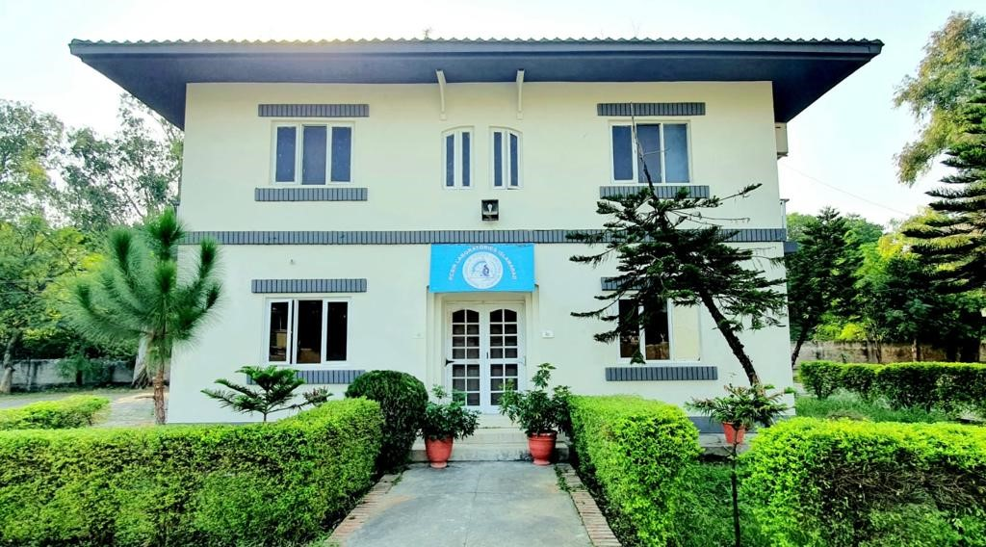
Figure 1: PCSIR Environmental Laboratory
2.National Metrology Institute of Pakistan (NMIP):
- Provides water and environmental testing services.
- Field:
Testing and Calibration
- Sub-field:
Food Testing ,Water Testing, Water Testing, Environmental Testing, Calibration
- Location:
Plot No.16, Sector H-9/1,Islamabad, Pakistan
3.Pakistan Environmental Protection Agency (Pak-EPA):
- Operates a lab (CLEAN Laboratory) that can analyze water pollution and is equipped to conduct field activities as well.
CLEAN Works in the Following Areas
- Analysis of municipal, industrial effluent and other environmental related samples
- Research/Investigation to identify different pollutant affecting public health
- Establish national procedures and methodologies for testing NEQS parameters
- Training to Provincial Environmental Protection Agencies, industrial sector and non-government organizations (NGOs)
- Propose amendments in the NEQS, if and where required based on the technical investigation
- Provide research facilities to different universities and institutions
Location:
H-8/2 Islamabad, Pakistan
4.National Institutes of Health (NIH):
- The Institute of Nutrition and Health at NIH offers water sampling and analysis services.
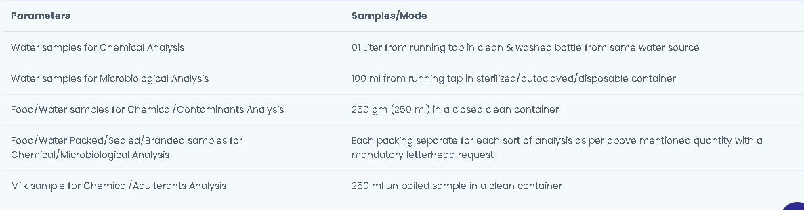
Figure 2:PARAMETERS AND SAMPLES OF NIH
Location:
National Institutes of Health (NIH) Park Road, Chak Shahzad, Islamabad, Pakistan
Pakistan Agricultural Research Council (PARC):
The Center of Excellence for Water Resources and Irrigation (CEWRI) have research facilities that could be relevant, with a location in Fatehjang, not far from Rawalpindi.
The Institute has a team of 24 trained multi-disciplinary professionals (scientists/engineers) supported by over 40 skilled staff and well-equipped laboratories, soil, water and weather monitoring systems. The research is mainly aimed at devising innovative solutions and management strategies for the conservation of water resources under the changing climate and addressing the rising energy cost through promotion of alternate energy use in agriculture.
- Drip and sprinkler testing laboratory
- Waste water treatment and reuse
- Solar and bio-gas testing laboratories
- Soil and water testing laboratory
- Groundwater investigation & assessment services
- Watershed management and demonstration site at Satrameel
- Remote Sensing and GIS labs
- Agriculture information dashboard
Location:
Plot No. 20، 1 Ataturk Ave, G-5/1 G-5, Islamabad
Water testing lab in Rawalpindi:
1.WASA (Water & Sanitation Agency):
It has its own lab doing regular monitoring of physical, chemical & bacterial parameters (appearance, pH, turbidity, hardness, arsenic, etc.).
Area:
Rawal Lake Filtration Plant; filtration plants, tube wells etc in WASA area.
Location:
WASA Headquarter, Liaquat Bagh, Murree Road, Rawalpindi.
2.Soil & Water Testing Lab & Research Center, Rawalpindi:
Offers water analysis and environmental lab services. Accredited for water testing.
Location:
Data Ganj Bakhsh Rd, Shamsabad, Rawalpindi
3.Agriculture Department / AARI Services:
Soil & Water Testing Lab for Research — they do water quality & also services geared toward agriculture but may process drinking water related parameters.
Location:
Data Ganj Bakhsh Murree Road, Rawalpindi

